**Optimization of 3D printing of ceramic components**

MTP Phase 1 Report

by

**Gholpe Amay Bhalchandra**

Roll. No. 214103205

Under the supervision of

**Dr. P.S.Robi & Dr. Sukhomay Pal**



**Department of Mechanical Engineering**

**Indian Institute of Technology Guwahati**

**Guwahati – 781039, Assam, India**

**October, 2022**

**Acknowledgement**

It is a genuine sense of pleasure to express my sincere thanks and gratitude to my MTP supervisor, Prof. P S Robi and Prof. Sukhomay Pal, Department of Mechanical Engineering, IIT Guwahati, for his support, guidance, and cooperation during this project to date. He has always been an inspiration to me and I have learned a great deal from his methods, vision, and thought process.

I would also like to extend my sincere thanks to my parent who has been a source of constant support right from the decision of pursuing M.Tech. at IIT Guwahati. It is only because of the values and discipline taught to me by them, that I have reached so far.

Lastly, I would like to thank the Ministry of Education (MoE), Government of India, for providing me the scholarship because of which I could manage my finances well and my M.Tech. journey has been so smooth so far.

Gholpe Amay Bhalchandra

16th October 2022

**Abstract**

Along with extensive research on the three-dimensional (3D) printing of polymers and metals, 3D printing of ceramics is now the latest trend to come under the spotlight. The ability to fabricate ceramic components of arbitrarily complex shapes has been extremely challenging without 3D printing. This review focuses on the latest advances in the 3D printing of ceramics and presents the historical origins and evolution of each related technique. The main technical aspects, including feedstock properties, process control, post-treatments and energy source–material interactions, are also discussed. The technical challenges and advice about how to address these are presented. Comparisons are made between the techniques to facilitate the selection of the best ones in practical use. In addition, representative applications of the 3D printing of various types of ceramics are surveyed. Future directions are pointed out on the advancement on materials and forming mechanism for the fabrication of high-performance ceramic components.

|  |  |
| --- | --- |
| Contents | |
| List of figures | 6 |
| List of Tables | 6 |
| Chapter 1. Introduction | 7 |
| 1.1 Introduction | 7 |
| 1.2 Ceramic 3D Printing   1. Stereolithography 2. Selective Laser Sintering 3. Selective Laser Melting 4. Fused Deposition Modelling 5. Laminated Object Manufacturing 6. Direct Ink Writing   1.2.6.1. Slurry  1.2.6.2. Printability  1.2.6.3. Debinding and sintering | 9  10  12  14  16  18  20  20  23  23 |
| Chapter 2. Literature Review   1. Direct Ink Writing of Alumina Ceramics 2. Direct Ink Writing of Other Ceramics 3. Literature Summary 4. Research Gap 5. Objectives of the present work | 25  25  26  30  35  35 |
| Chapter 3. Experimental Procedure | 36 |
| Chapter 4. Future Scope | 42 |
| Chapter 5. Conclusion | 43 |
| References | 44 |

List of Figures

1. Schematics of stereolithography
2. Schematics of SLS
3. Schematics of SLM
4. Schematics of FDM
5. Schematics of LOM
6. Slurry Preparation
7. Relation between Viscosity, Shear Rate, Shear Stress
8. Fine Metodology
9. FESEM of Alumina Powder (250 µm)
10. EDX image of Alumina (wt%)
11. XRD Plot of alumina powder
12. Plot of viscosity and shear stress of slurry vs shear rate, (a) Sample –A, (b) Sample-B, (b) Sample-C and (d) Sample-D.

List of Tables

Table 1 Overview of slurry

Table 2. Details of concentration of alumina and binders

**Chapter 1**

**Introduction**

Manufacturing is an important part of engineering where, during production obtaining the desired shape for the components with the desired attributes is done in part. There are several types of manufacturing techniques and each having its advantages and limitations. Over the last few centuries manufacturing was carried out by casting and machining technique or by material removal method. In the recent few decades, additive manufacturing has been introduced which has a lot of advantages material compared to machining techniques like achieving the desired shape, obtaining complex shapes which otherwise would be impossible with other techniques, reduction in the wastage of raw materials, high precision and extensively used for rapid Prototyping.

As opposed to subtractive manufacturing, additive manufacturing is the process of adding materials to make objects of a 3D model, usually layer upon layer, and finally achieving the desired shape and dimensions. There are several methods of additive manufacturing such as Stereolithography (STL), Selective laser sintering (SLS), Selective laser Melting (SLM), Digital Light Processing DLP, Inkjet Printing (IJP), Fused Deposition Modeling (FDM), Laminated Object Manufacturing (LOM) and Direct Ink writing (DIW). Extensive use of additive manufacturing so far is confined to 3D printing which generally is sued with polymer material though in few cases manufacturing of composite materials are also possible. When it comes to manufacturing costly materials or advanced materials including metallic, alloys and ceramics at the stage of development, the main techniques for metals are SLM, SLS, Powder Bed Fusion, Electron Beam Melting. In metallic material, the drawbacks are high. The recent focus of attention is to manufacture engineering ceramic components. Additive manufacturing (AM) techniques of ceramics bring opportunities for rapid fabrication of complex shaped ceramic components in a range of structures from macroscale like e.g., in thermal protection systems to microscale level. The high melting point of the ceramic material is an impediment to the manufacturing of ceramics material, however in some cases it can be very effectively utilized for manufacturing ceramic materials by 3d printing. Additive manufacturing of ceramic materials is mainly depositing a slurry, layer by layer. A summary of slurry is depicted in Table 1. With the increasing demand for complex ceramic structures, several additive manufacturing techniques have been successfully developed, such as Direct Ink Writing (DIW), Stereolithography (SLA), Fused Deposition Modeling (FDM) and Binder jetting (BJ). However, most of these techniques are slurry and powder based and often involve a time-consuming binder removal process. densification into a dense part (sintering) is generally rather difficult due to the burn-out of large amounts of organic additives, leading to unavoidable residual pores and sacrificing the print resolution[1] Ceramic components with highly complex structures that are extremely difficult to fabricate using conventional manufacturing methods can now be processed via 3D printing techniques. The high melting points of ceramics impose a greater demand on the fabrication process. Ceramic 3D printing is also well suited for creating objects that need to be strong and durable. Ceramics are known for their strength and durability, making them ideal for applications such as medical implants and industrial parts.

**Table 1: Overview of slurry**

|  |  |  |
| --- | --- | --- |
| **Slurry Based** | **Powder based** | **Bulk solid technologies** |
| Stereolithography (STL) | 3d printing(3DP) | Laminated object printing (LOM) |
| Direct Ink Writing (DIW) | Selective Laser Melting (SLM) | Fused deposition modelling (FDM) |
| Digital light processing (DLP) | Selective Laser Sintering (SLS) | ---- |
| Ink jet printing (IJP) | ---- | ---- |

**3D Printing of Ceramics**

Ceramics are agile and adaptable materials because of their exceptional qualities, including great mechanical strength and hardness, high oxidation resistance, and strong chemical and thermal stability with or without binders and other additives, ceramic goods are often shaped into the necessary forms using traditional processes including injection molding, die pressing, tape casting, gel casting, etc. However, these methods are always constrained by their high duration, high expense, and limited accuracy. Moreover, because molding and pricey tooling are required, it is difficult to make complicated shaped geometries such as pieces with interior holes or curved surfaces. The net shape of 3D ceramic components may be manufactured using AM as a substitute for the traditional formative technique without the use of expensive tooling. The development of 3D printing in the production of ceramic components opens up new avenues for tackling difficulties and constraints. 3D printing is a competitive manufacturing technology, which has opened up new possibilities for the fabrication of complex ceramic structures and customized parts.[2] There are major 4 ceramics widely used in 3d printing 1: Al2O3 2: SiO2 3: ZrO2 4: SiC. As compared to metal ceramics have relative characteristics, high strength, brittleness hardness, high young's modulus; low toughness, density, thermal expansion, and electric conductivity.

Slurry-based Ceramic 3D printing technology allows green bodies to be fabricated at high packing densities. It involves liquid systems dispersed with fine ceramic particles as feedstock either in the form of inks or pastes, depending on the solid content. In this section, photo polymerization-based techniques such as Stereolithography along with Inkjet printing and extrusion-based Direct Ink Writing (DIW) are discussed[3].

1. **Stereolithography**

SLA is a unique 3D printing manufacturing process. When scanned through a non-curing resin, a programmed UV laser beam allows for photopolymerization of the first layer, followed by the creation of subsequent layers by moving the polymer reservoir down or up. This light-based 3D printing approach has been studied to create different bio-medical micro devices, including tissue scaffolds because of its unique characteristics of high-resolution and precise construction compared to other 3D printing methods, achieved by controlling the various aspects of the photons applied. Sometimes a single initiation is used for in situ polymerization, but due to its enhanced controllability, two-photon processes are gaining interest. Due to primary initiation, a higher-resolution SLA printer (100 nm) was developed to develop intricate structures. As a dust-free mounting device, SLA can be used to cope with difficulties with dust accumulation that especially occur during printing. However, processing time, permitted resin materials, complexity, and thermomechanical efficiency affect SLA. Figure 1.2 illustrates schematically the process of stereolithography.

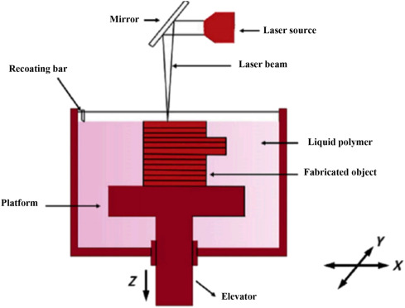

Fig.1.1 Schematics of Stereolithography [5].

**Advantages**

* Flexibility in choosing different light sources such as lasers, lamps or LEDs.
* Precision parts can be printed in minutes by exploiting high output speed and high resolution.
* The total printing time depends only on the thickness of the structure. Printing time for each layer is same no matter how complex or large the layer is.

**Disadvantages**

* Post processing of part is required to remove excessive resin due to the stickiness of resin.
* The current stereolithography parts do not possess impact strength and durability as compared to injection molded thermoplastics.
* Support structures are required to firmly attach the part to the print bed and prevent warpage.

**Applications**

* High elastic silicones for usage in soft robotics
* It has been explored in the field of microfluidics where small fluid volumes need to be precisely controlled through micro sized channels.

1. **Selective laser sintering**

In SLS, a laser is commonly used to create a part from a fine powder bed layer by layer. Fig. 1.2 shows a typical SLS setup. A high-power laser beam causes tiny particles to recrystallize (sinter) after it has irradiated them. Each layer is built using a deflection system that controls the scanning laser beam. The deflection system is driven by a corresponding cross-section computed from a predesigned CAD model. The following layer is then constructed by adding and distributing powder over the layer that has already been treated, and this cycle is repeated to create the entire 3D part. During the SLS procedure, the entire stack of layers is fused together to produce the desired shape as specified by the 3D model. A roller or a scraper typically makes up the SLS powder deposition system, which allows SLS to deposit successive powder layers with a thickness range of 20-150 micron. In order to prevent environmental contamination and unintended powder oxidation during the sintering process, powder deposition is typically performed under an inert atmosphere (e.g., argon, nitrogen). During the SLS process, the created item is supported by the unsintered powder bed, allowing for support-free production. The effective use of powder is a promising aspect of SLS because any leftover unmelted powder may be recycled. By maximising the crucial SLS processing parameters, such as laser power, powder bed temperature, laser scan speed, etc., the microstructures of porous structures and scaffolds can be regulated.

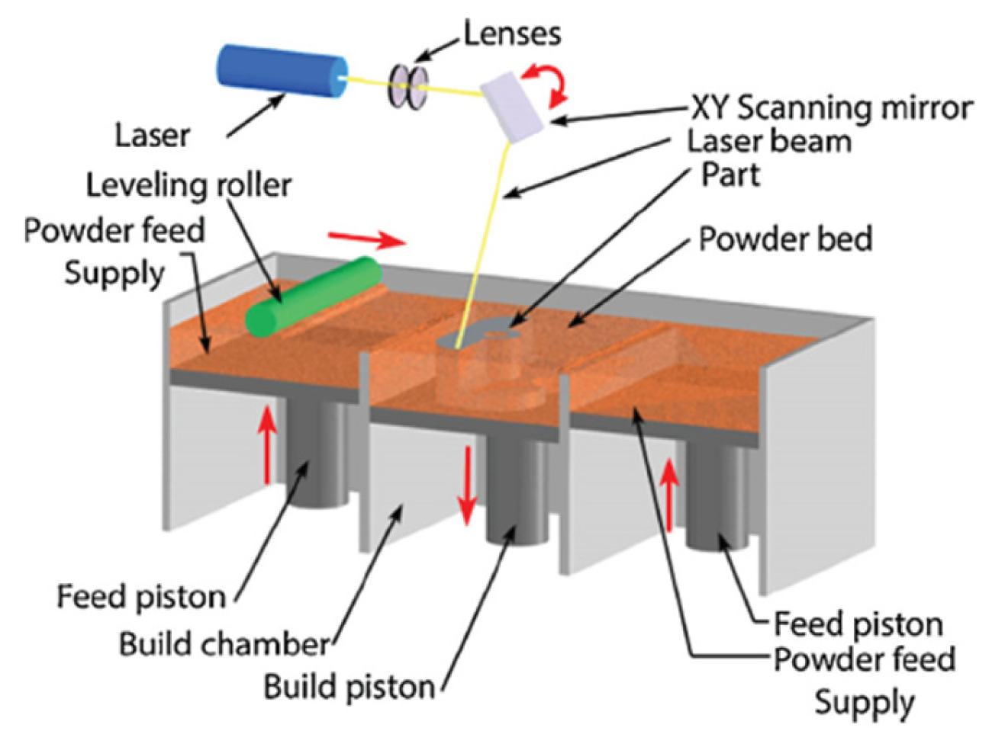

Fig. 1. 2 Schematics of SLS [4]

**Advantages**

* In SLS process, loose powder itself acts as a support material which saves significant time during part building and post processing.
* It has the capability to process wide range of materials such as polymers, metals, ceramics and composites.
* It enables fabrication of complicated shapes such as internal cooling channels.
* Post thermal treatments such as debinding, infiltration or sintering is eliminated.

**Disadvantages**

* Surface finish and accuracy is inferior to other liquid based process.
* Total printing time can take longer than other additive manufacturing process due to preheat and cool down cycles involved.
* Defects in the printed parts may be generated due to large shrinkage rates.
* Costly process as it requires high laser power and good beam quality.

**Applications**

* SLS technology is in wide use at many industries around the world due to its ability to easily make complex geometries with little to no added manufacturing effort.
* Its most common application is in prototype parts early in the design cycle such as for investment casting patterns

1. **Selective laser melting**

SLM, also referred as laser powder bed fusion (LPBF) or direct metal laser melting (DMLM), is an additive manufacturing (AM) process designed to melt and fuse metallic powders using a high power-density laser. The SLM technique works on the basis of applying very thin layers of metallic powder to a construction platform, which are later totally melted by the heat energy produced by one or more laser beams. The building platform is then lowered by a small distance and a new layer of powders are deposited and levelled by a re-coater. The laser beam(s) can be directed and focused through a computer-generated pattern by carefully designed scanner optics. Therefore, the powder particles can be selectively melted in the powder bed and form the shape of 3D objects according to the CAD design. When SLM is used on ceramic powder, full melting of the powder creates a solid component via layer-by-layer, high-energy density laser scanning, which eliminates the need for binders or post-sintering because the powder is fully melted and fused. As a result, it is anticipated that complicated components with greater purity, density, and strength would be manufactured in less time. SLM is thought to be the only 3D printing technique that permits the production of fully dense, highly durable, and intricately shaped ceramic objects from ceramic powders in a single step. Figure 1.3 refers to the schematics

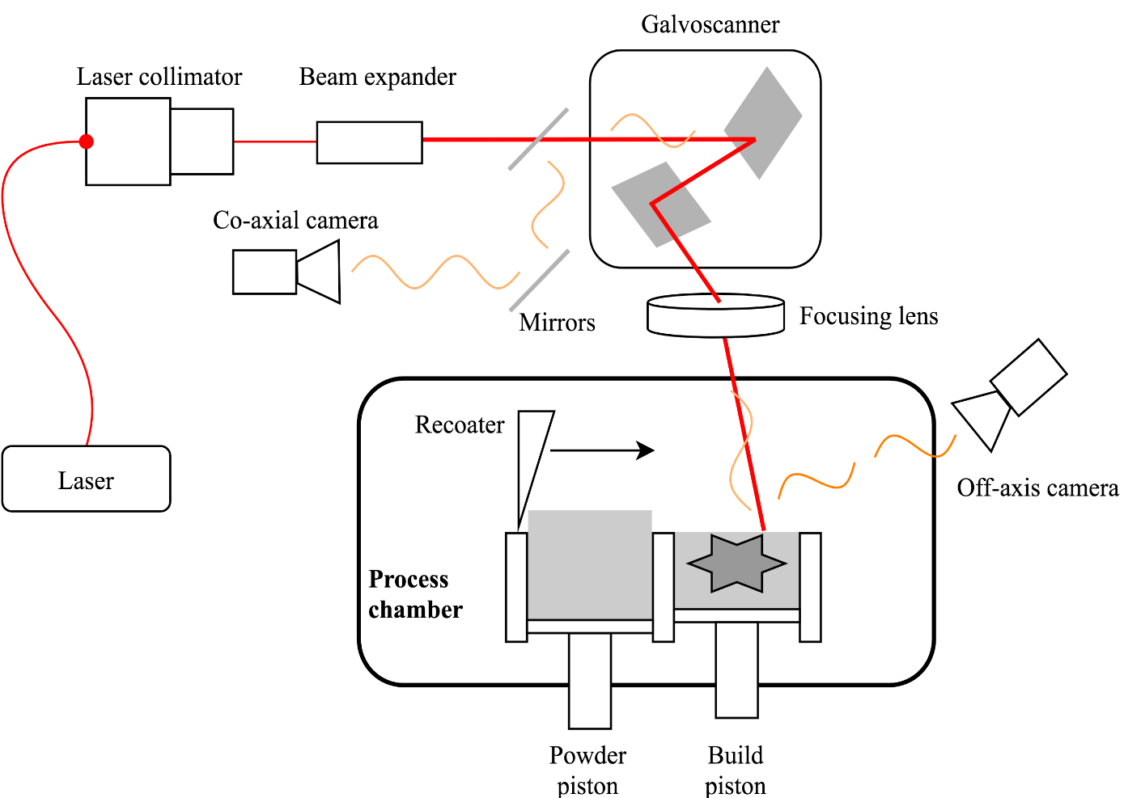

Fig.1.3 Schematics of SLM [2].

**Advantage**

* It eliminates time consuming and costly post processing operations for debinding, infiltration and post – sintering.
* It has the capability to produce complex objects as no special tooling is required like in casting and parts can be built in hours.
* It has the ability to tune the properties during processing of the parts.

**Disadvantages**

* The produced parts may have rough surfaces depending on powder size and the process parameters.
* Brittle materials and high temperature parts cannot accommodate high internal stresses which may lead to cracking of the parts depending on the cooling rate.
* Optimization of the process parameters is time consuming.

**Applications**

* Medical and dental applications

1. Biomedical metal framework for dental prosthesis
2. Body implants of cortical bone made from 316L stainless steel
3. Orthodontic products

* Heat Exchangers

1. Conformal cooling channels made of Inox904L steel
2. Furnace fixtures. Heat exchange piping, turbine blades in jet engines

* Light weight structures

1. Cellular lattice structures
2. Honeycomb structures with negative Poisson ratio which can be applied as crash impact absorbers in bullet proof vest and artificial intervertebral discs.
3. **Fused deposition modelling (FDM)**

Fused deposition modeling (FDM) is one of the most widely used [additive manufacturing processes](https://www.sciencedirect.com/topics/engineering/additive-manufacturing-process) for fabricating prototypes and functional parts in common engineering plastics. FDM uses a layer-by-layer deposition technique, in which molten polymers or ceramics are extruded through a nozzle with a small orifice, which merges with the material on the previous layer. The substance quickly hardens over the previously printed layer after extrusion. When the part is finished, supports can be constructed and then removed. The pattern for each layer is controlled by mechanical manipulation of the x-y position of the nozzle and can be different or arbitrary for each deposited layer. This technique has been applied to the production of three-dimensional scaffolds using polymers (PCL, high-density polyethylene) and composites (PCL/ hydroxyapatite). A schematic representation of the FDM procedure is shown fig.1.4.

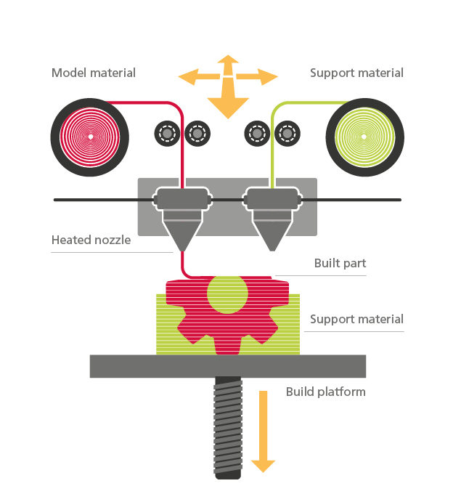

Fig. 1.4 Schematics of FDM [20].

**Advantages**

* As most of the filaments are plastic based, they can be reused and easily shaped.
* There is less exposure to toxic chemicals, lasers or liquid chemical bath.
* Wide range of filament is compatible such as PLA, ABS or PTEG

**Disadvantages**

* The actual shape produced is dependent on the nozzle, acceleration, and deceleration characteristics, and the viscoelastic behaviour of the material as it solidifies.
* Relatively low accuracy and poor surface finish.

**Applications**

* Rapidly used in tissue engineering and developing patient specific implants for prosthesis and bones.
* The development of polymer composites with good electrical properties and filament processability has led to applications in dielectric, conductive, sensors and energy storage applications.

1. **Laminated Object Manufacturing (LOM)**

Laminated Object Manufacturing also known as Sheet lamination, shares similar building principles with other AM processes, but instead of using powder or wire as feedstock, sheet lamination uses foil to make an object. In the paper-based lamination, papers/foils are glued together layer by layer and precisely cut to the designed geometry to make the final object. Potentially any sheet material that can be precisely cut using cutting tools (laser or mechanical cutter) and that can be bonded can be used for part construction. The paper thicknesses usually range from 0.07 to 0.2 mm. Composite lamination has a similar principle, but some reinforcement can be added to the buck material to improve the strength of the fabricated part. laminated materials (paper, metal, plastic) are employed to form the layer using a cutting tool. fig.1.5 schematics of LOM Then, the excess material is removed and the step is repeated, stacking the layers with good adhesion through adhesive or welding techniques, depending on the type of material.

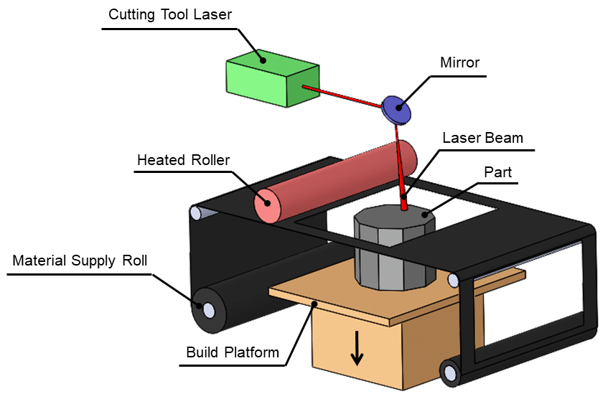

Fig. 1.5 Schematics of LOM [7].

**Advantages**

* Low shrinkage, residual stress and distortion problems in this process
* Large parts can be fabricated quickly
* Nontoxic, stable, and easy-to-handle feedstock
* Wide range of build materials (paper, polymer sheets, metal or ceramic filled tapes)

**Disadvantages**

* Most paper-based parts require coating to avoid moisture absorption and excessive wear.
* Controlling part accuracy in z direction is difficult due to swelling or inconsistent sheet material thickness.
* Inhomogeneous mechanical and thermal properties due to use of glue in laminated structure.

**Applications**

* Al/SiC metal matrix composites
* Optical Fibers
* Smart structures such as Sensors, actuators, thermal management devices

1. **Direct Ink Writing (DIW)**

Possibility for the additive production of ceramic objects by extrusion is direct ink writing (DIW), a process in which a highly viscous raw material is extruded in layers at room temperature. This method, also called robocasting (RC), for processing ceramic masses with a low organic content was developed in 1997. The spectrum of applications ranges from the production of ceramic composite components to filter and battery technology to medical or artistic applications. Robocasting is also a promising method for the production of ceramic parts for construction applications. The process is characterized by its ability to produce complex shapes cheaply and quickly. The high solid content in the raw material ensures that the blank retains its shape in the finishing process[4].

1. **Slurry Preparation**

The slurry needs to exhibit the appropriate rheological behavior. In order to produce continuous filaments, it must, on the one hand, have a viscosity that is low enough to pass through nozzles at low pressure without clogging. On the other hand, it must be able to maintain the form of the nozzle and have enough yield strength and stiffness to sustain layer stacking. The colloidal suspension of ceramic particles (40–50 vol% or 60–80 wt%), binder materials, deionized water, and appropriate additives make up the slurries for DIW. To disperse the particle clumps and guarantee thorough mixing, the suspension is next ball milled in a planetary mixer. Degassing is then performed on the resultant slurry to release any retained air. In general, any agglomeration or air bubble must be eliminated before printing and the slurry must be homogeneous. The number of solids in the slurry is of utmost significance. Fig.6 displays the comprehensive schematic for the creation of the ceramic slurry. High solid loading is generally incorporated into the suspension designs since it raises the yield stress needed to preserve structural integrity[5]. Additionally, high solid loading raises the density of the green body to maximize densification and minimize dimensional error in the finished component. The compatibility of the organic binders, additives, dispersants, and plasticizers must be carefully adjusted as it relies on the ceramic material[6].

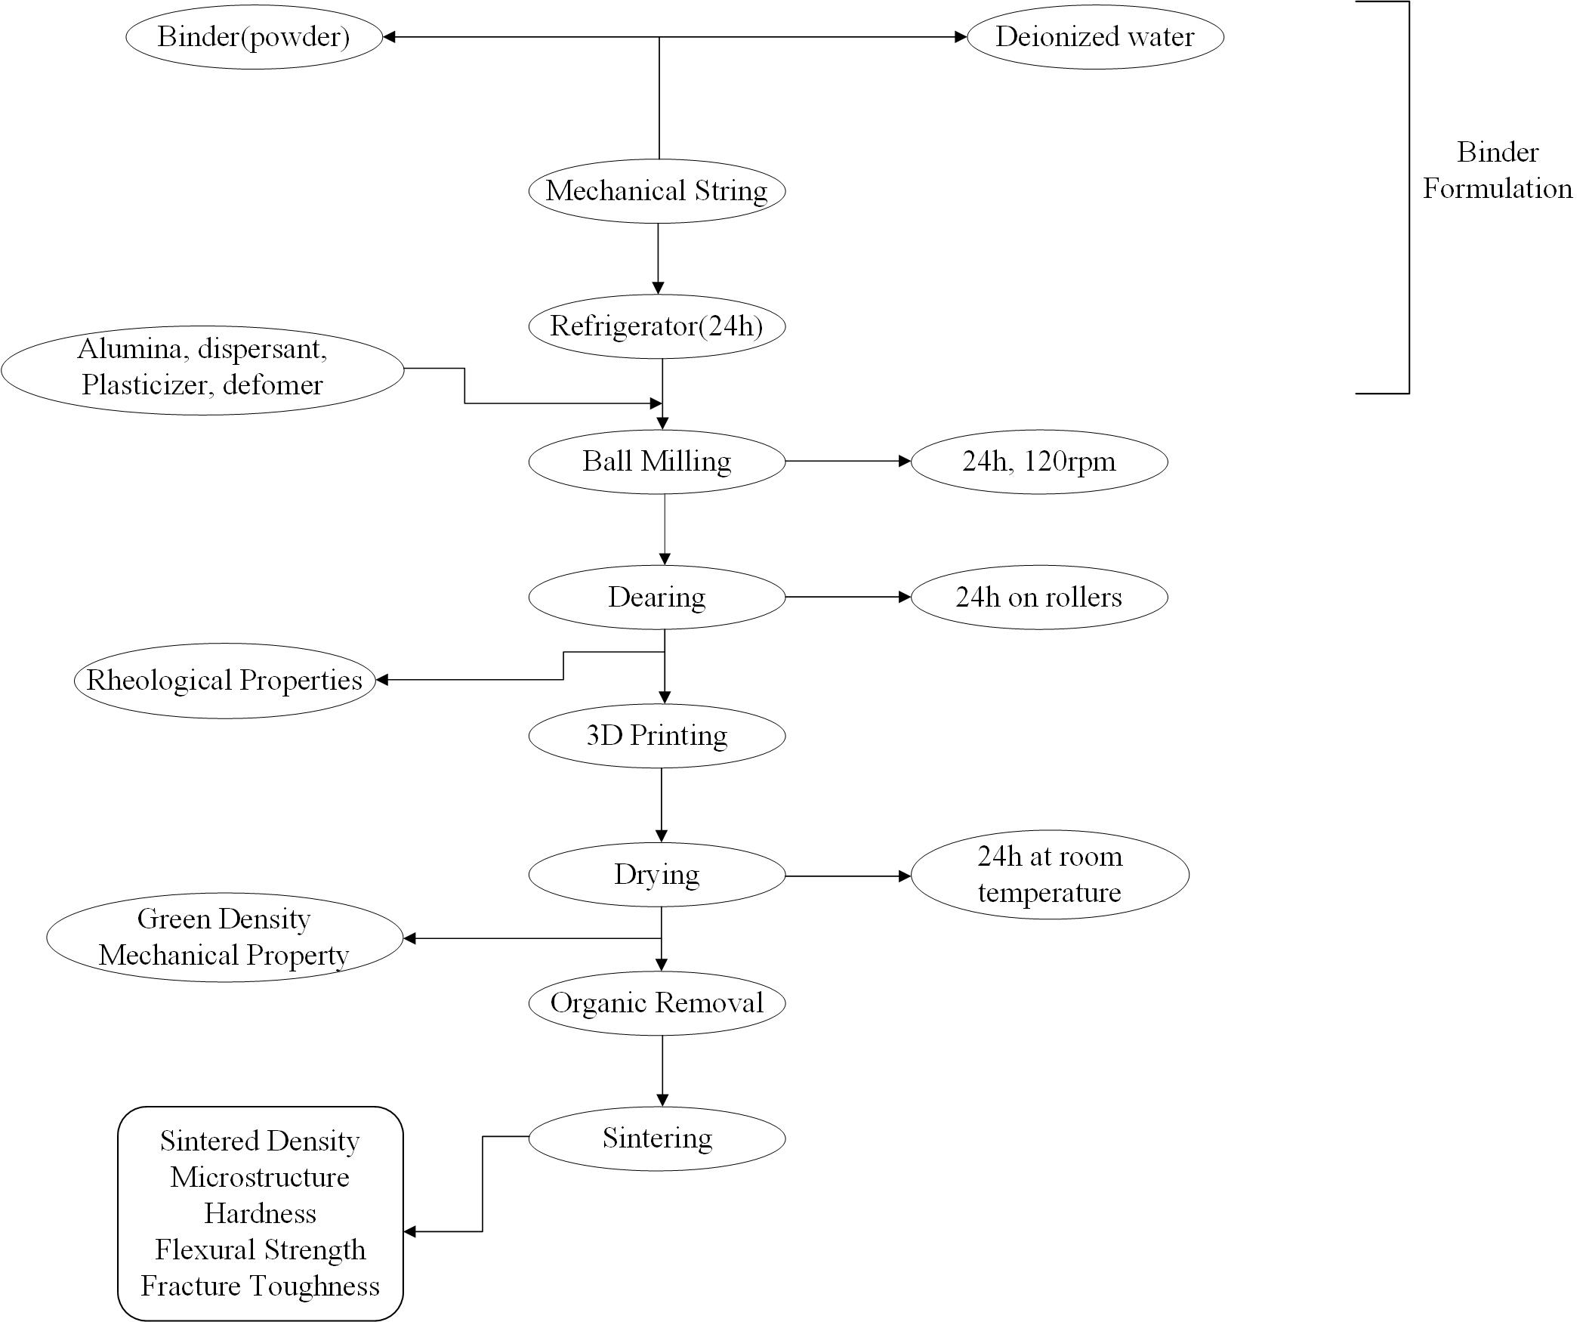

Fig.1.6 Slurry Preparation method

1. **Printability**

Printable ink is one of the stringiest requirements in DIW process as it affects the resolution, accuracy, surface finish and properties (mechanical, electrical, optical) of the printed specimen. During DIW, deposition of highly concentrated colloidal suspensions (ink) is done by extruding through conical nozzle without clogging. Nozzle size greatly affects the resolution of the printed part. Small nozzle size (less than 200μm) enhances the printing resolution but it increases the extrusion pressure and build time quite significantly. The uniqueness of this process is that the whole process occurs at room temperature as the printability relies on rheology. Thus, optimizing the rheological property is critical in DIW which can be altered using carious means such as chemical modification of ink, fine tuning of solid loading, binders, dispersants etc. After the desired rheological properties is obtained, the slurry is injected in the barrel. It should be ensured that no air bubbles get entrapped in the nozzle path, which otherwise could lead to clogging issues. The nozzle is then moved to the desired path generated by the G-Code using the slicer software. The accuracy of the final printed path by DIW process depends on Solid loading, Rheology of the suspension, printing speed and drying and sintering mechanism[7].

1. **Debinding And sintering**

Before sintering, the organic additives and other processing aids must be taken out of the green body. Debinding is the process of removing the binder. If the binder content is significant, debinding might be a crucial step in the production of ceramics. Solvent and thermal debinding are the two phases in the binder removal process. The green component is submerged in a suitable solvent at various temperatures and immersion times to perform solvent debinding. The melting temperature of the binders is used to calculate the temperature for solvent debinding. Thermal debinding is the process of removing the binder as a vapor by heating it at room temperature in an oxidising or non-oxidizing atmosphere, or even partially under vacuum. Both chemical and physical factors have an impact on it. After debinding, and sintering process is completed in a sintering furnace that offers a controlled atmosphere and temperature. One of the most crucial processes and a special phenomenon in the creation of ceramic parts is sintering. Volumetric shrinkage, densification, reduction of pore volume and size, significantly increased mechanical strength, and grain coarsening are important outcomes of the sintering process.

**Chapter 2**

**Literature Review**

**Introduction**

This chapter discusses the overview of the literature review of different types of advanced ceramics like Alumina, Zirconia and other advanced ceramics like Boron Carbide (B4C), Silicon Oxycarbide (SiOC), Ti2AlC, Titania and Molybdenum Di silicide (MoSi2). The literature review consists of study about the different additives suitable for these ceramics, rheological behavior of ceramic suspensions, the effect of printing parameters like layer thickness, nozzle size, printing speed, raster angle, infill density etc on the printability of these ceramics.

1. **Direct ink writing of Alumina Ceramics**

Alumina is a ceramic material that is known for its excellent mechanical and thermal properties such as high elastic modulus, low thermal conductivity, excellent compressive strength, superior wear and corrosion resistance and maintain thermal and chemical stability at higher temperature.[8]

**Alvarez at al** [9]created new DIW α-Al2O3 catalysts with various shapes and infill to increase the catalytic efficiency, a proper scientific study has been carried out to optimize both ceramic ink formulation and heat treatment. Due to the fact that printed architectures allow for longer residence periods to be attained for the same volume, DIW structures exhibit greater catalytic performance than commercially available materials.

**David et al** [10] have been shown that near full-density (greater than 99% relative density) transparent ceramics of different shapes and sizes can be produced with optical quality comparable to that attained by more traditional processing techniques for transparent ceramics, such as CIP, using an extrusion-based 3D printer and post-processing steps like debinding, vacuum sintering, and polishing. The utilization of improved slurry and printing process parameters, as well as a two-step sintering profile, resulted in the highest-grade 3D printed transparent ceramics. By using standard techniques, it would be more expensive and time-consuming to create transparent ceramics of different sizes and shapes. processes.

**Ghazanfari et al**. [11] were able to successfully print several dense, and complicated shape alumina pieces with density values that were near to theoretical By modifying the robocasting process and calling it the Ceramic On-Demand Extrusion (CODE) method. In this modification, the part was printed inside a tank of mineral oil, and to prevent dehydration from the edges of the layers, the freshly formed layer was dipped into oil (just below the upper surface). The freshly deposited layer was then evenly dried using infrared radiation in order to improve the part's yield stress and form retention. Each layer of the component was Printed using the same process, which was repeated. the slurry was composed of Alumina powder with a solid loading of 60%, deionized water, ammonium polymethacrylate, and methylcellulose. With no visible printing flow, the researchers were able to effectively build very complicated items including an impeller, a gear, and a solid spherical object.

In the work of **L. Yang et al**.[12] a new AM printing of aluminum oxide components via heat-induced Direct Ink Writing was developed. The slurry was prepared by mixing 50 vol% solid loadings of alumina with 0.4 wt% [carrageenans](https://www.sciencedirect.com/topics/engineering/carrageenan" \o "Learn more about carrageenans from ScienceDirect's AI-generated Topic Pages) as an additive. Their findings showed that the slurry exhibited a [pseudoplastic fluid](https://www.sciencedirect.com/topics/engineering/pseudoplastic-fluid) property, which is desirable for the robocasting as can be seen in fig . The non-linear tendency implying that the blend is a non-Newtonian shear-thinning fluid. The slurry for DIW must have optimized flow with minimum shear force and enough strength to maintain the shape integrity. Figure 2.1 showed slurry viscosity with and without the accumulation of additive carrageenan when the temperature was rose from 20 °C to 70 °C. The space between two neighboring lines was 200 μm, causing in comparatively good surface finish. Moreover, the grains were found to be very much homogenous proving that the slurry could be uniformly distributed under high-speed [mechanical agitation](https://www.sciencedirect.com/topics/engineering/mechanical-agitation). The condensed ceramic parts with a comparative density of 98% were achieved by heat-induced solidification. The sintered samples displayed a [linear shrinkage](https://www.sciencedirect.com/topics/engineering/linear-shrinkage) of 12%. Hence, an adjustment of 12% expansion in the pre-sintered part could manufacture near the net-shaped ceramic part.

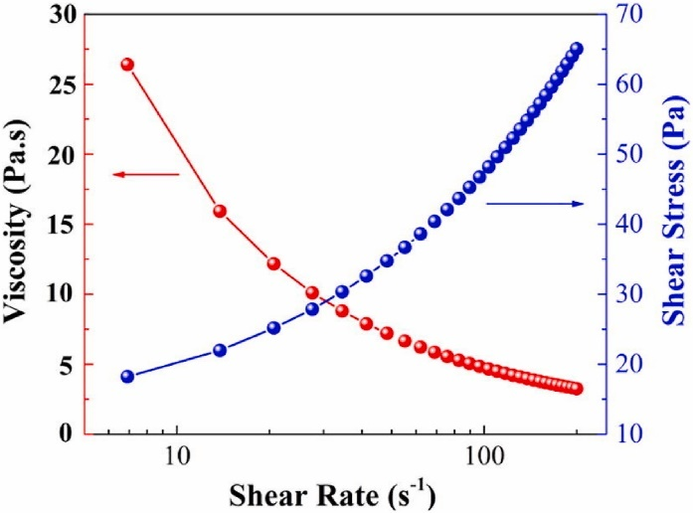

**Fig. 2.1** Relation between Viscosity, Shear Rate, Shear Stress

**Sindi et al** [13] applied this method, dense objects can be machined into complex shapes at a lower cost and in less time. The preparation of the gel casting fluid has a significant impact on the characteristics of the alumina components that are formed. The final relative density and mechanical characteristics of the pieces produced were significantly influenced by the de-airing procedure and the solids loading. The manufactured pieces' density and mechanical characteristics are on par with those of parts made using conventional methods. The solids loading, sintering temperature, and deairing all have an impact on the relative densities that are achieved.

**Shi et al** [15] using carrageenan as a thermocuring binder for printing alumina ceramic in three dimensions. He set the paste's solid loading at 50% by volume. At 65oC, a significant rise in viscosity of the paste containing 0.4 wt% carrageenan was seen. The team created pore-free thin-walled alumina ceramic pieces with effective fabrication. [16] looked at how the printing parameters affected the physical and mechanical characteristics of 3D printed alumina and zirconia items. In his investigation, flexural strength, microhardness, and toughness were associated with printing parameters like part orientation and extrusion velocity. The most important factor for microhardness and flexural strength, it is discovered, is part orientation. Alumina and zirconia produced by 3D printing have fracture toughness that increases with elastic modulus and flexural strength while decreasing with hardness and sintered density.

**Liu et al** [17] reported the use of low-temperature DIW for the preparation of LiFePO4 (lithium iron phosphate) electrodes. Their results showed improvements in the performance of printed electrodes due to their highly porous structures as a result of low-temperature printing.

**Barki et al** [18] arrived at the bohimen expect to be an accurate printability for other DIW inks because it links physical parameters that not related with the chemical properties of the slurry. Thus, while it is not evident that all starting materials can result in inks with the rheological properties necessary for printability, those with a near one should be capable of producing high density and high strength materials like those were demonstrated.

1. **Direct ink writing of other ceramics**

**Savio et al** [19] has studied the suitability to fabricate MoSi2 using slip casting technique. The slurry was prepared starting from 45% solid loading (MoSi2 powder) to 75 wt% in the 10.7 pH aqueous solution which consisted of hydrochloric acid and ammonium hydroxide solution. It was observed that densities of sintered sample increase with solid content and reached maximum at 50 wt%, then decreased further with increasing solid loading. They successfully casted and sintered MoSi2 cylinders (i.d. = 11 mm, o.d. = 20 mm and height = 15 mm) and seals (length = 40 mm, width = 6 mm and thickness = 2 mm).

**Zhu et al** [20] investigated the influence of printing parameters and effect of slurry composition on the performance of Al2O3 refractory products. They prepared the slurry which composed of Alumina powder (with a purity of 90%, and particle size of 75 μm) as the raw materials, silica fume (with a purity of 96% and D50 = 0.2 μm) as the binders, and water as the solvent. The amount of silica fume was 7 wt%. The solid content of slurries was prepared as 57, 60, 63, 66 vol%. They found that the slurry with solid content of 63 vol% was optimum for Direct Ink Writing based on the rheological study. They reported that as the layer height decreases, the void area also decreases and the layer height has significant effect on the inter space area. They observed that as the nozzle travel speed increases, a large dimensional deviation was observed. It was reported that the flexural strength was enhanced from 45 MPa to 61 MPa when the layer height decreased from 1.8 mm to 0.8 mm. It was concluded that the samples prepared with a layer height of 0.8 mm showed superior slag resistance and a flexural strength of 61 MPa after sintering at 1600 °C for 3 h.

**Shi et al** [15] successfully printed Zirconia ceramic teeth using 3D inkjet printing method and characterized the properties of ceramic ink and mechanical performance of sintered samples. They used 3wt% ammonium citrate as dispersants to produce the suspension. They observed that higher solid loading suspensions such as 56 vol% settled quickly within few minutes and was not suitable for printing. They reported that when the extrusion pressure exceeded 0.4 MPa, the extrusion material does not increase which is due to the friction between 32 the high viscosity ink and the nozzle tube. It was reported that with the printing speed of 15 mm/s, the zirconia ceramic teeth were fabricated in less than 5 min.

**Quinn et al** [21] A multi-material DIW technique has been successfully used by Chao Xu et al. to manufacture complex steel structures by forming detachable support made from copper (low melting temperature than steel) and alumina (high thermal and chemical stability than steel). During sintering, copper completely infiltrated into the pores of steel structures to create a hybrid structure where alumina offered a brittle easily removable support. They investigated the impact of the support material on the steel structure characteristics by describing important printing parameters such as porosity, electrical conductivity, and [tensile strength](https://www.sciencedirect.com/topics/engineering/tensile-strength) of the filament along with surface roughness. The alumina support is found to be stable chemically during the sintering process, causing no undesired foreign particles to the steel structures. The polymer binder solution was used as a binding material which was prepared by adding 2 g of [polylactic acid](https://www.sciencedirect.com/topics/materials-science/polylactide) to 8 g of [dichloromethane](https://www.sciencedirect.com/topics/engineering/dichloromethane). reveals optical and scanning electron microscopy images of as-printed and [sintered steel](https://www.sciencedirect.com/topics/engineering/sintered-steel), steel-copper, and steel-alumina scaffolds.

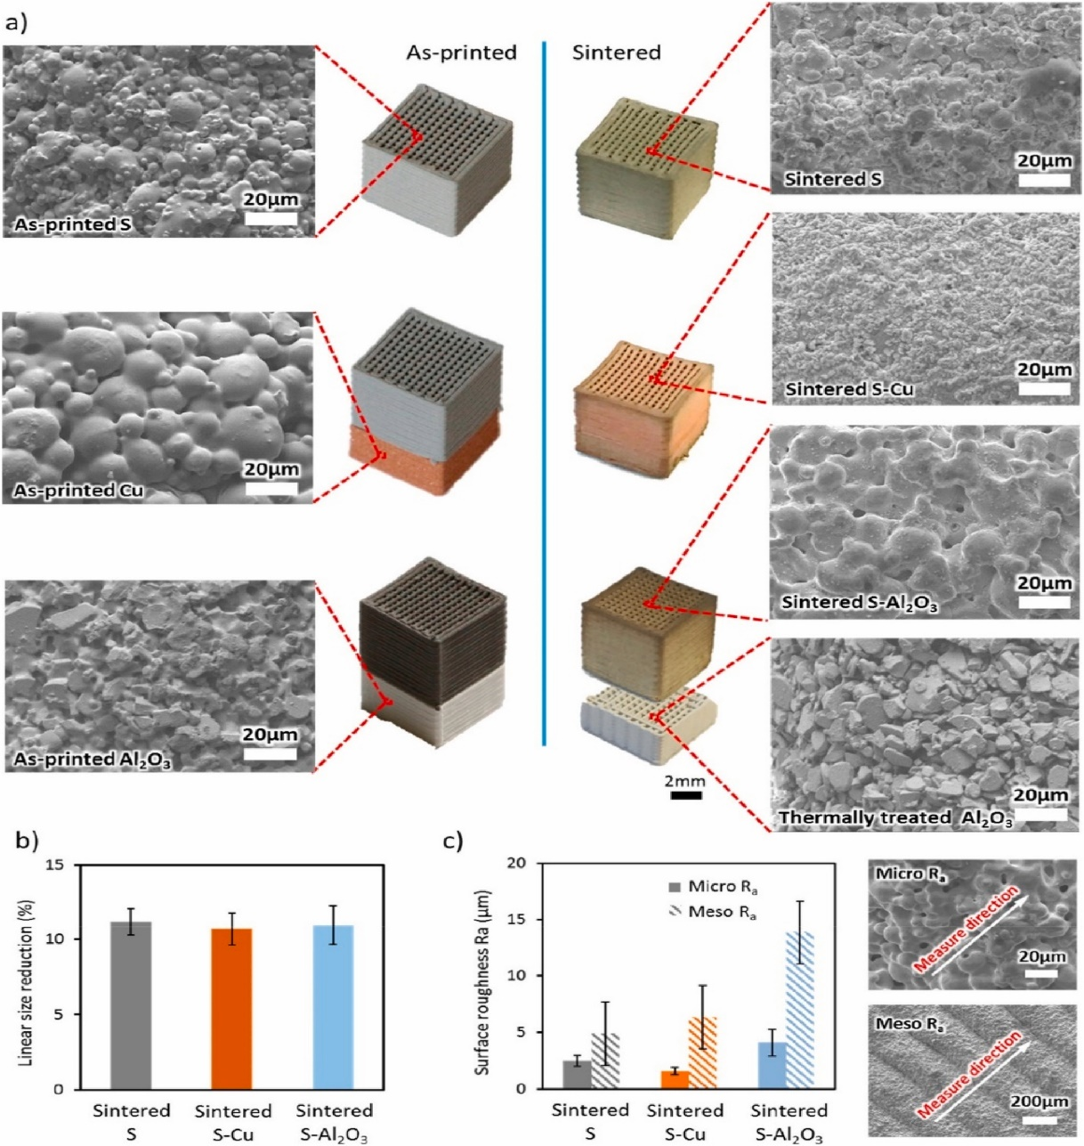

**Fig, 2.2** Before and after sintering scaffolds images. b. reduction in size after sintering process. C. surface roughness.

**Minasyan et al** [22] MoSi2 is a high temperature ceramic that was used to create open pore ceramic cellular lattice meso-structures with complex geometry by adding the toughening agent Si3N4. This was done using the Selective Laser Melting Additive Manufacturing process and a Yb: YAG fibre laser with a maximum power of 120 W and a wavelength of 1.07 m. For the combustion-based synthesis of MoSi2/Si composite powders, the researchers used elementary Mo and Si powders. The particle size of MoSi2/Si powder was estimated to be 3–10 m based on SEM images. It was noted that the printed lattice appeared brittle and breakable during removal of support when using low laser current of 1000 mA, demonstrating that laser current has a significant impact on the sintering process. Sintered samples' XRD results revealed no new phase detection.

**Shao et al** [23]developed a new printing technique called 3D Gel Printing to create complex-shaped Zirconia Ceramic parts using a 2-hydroxyethyl methacrylate (HEMA) gelation system. As a dispersion, the researchers utilised ammonium citrate. According to a report, when the shear rate is greater than 1000 s1, the viscosity of the slurry with solid loading greater than 50 vol% cannot be measured. The results of a visual inspection revealed no flaws. The fracture morphology of the printed samples showed several short cracks, indicating that the bonding between the layers has to be further strengthened. In contrast, the fracture morphology of the sintered samples showed no defects or holes.

**Schwarz et al** [24] reported that in an effort to create oxygen-free MoSi2 and maintain tight control over second phase additions, high energy mechanical alloying was used to manufacture MoSi2 and MoSi2 based alloys beginning from pure elements. Researchers looked into the compositions of: Starting with elemental powders, MoSi2, MoSi2 -27 mol% Mo5Si3, MoSi2-50 mol% Mo5Si3, and MoSi2-50 mol% WSi2. Molybdenum powder that was 99.9% pure and had a mesh size of 325 and silicon powder that was 99.9999% pure made up the beginning powder. By using Energy Dispersive X-Ray Spectroscopy, they discovered that tungsten could not be detected in any of the alloys, but it could be found in the (Mo, W) Si2 alloy. They claimed that moderate hot-pressing temperatures could nevertheless produce high densities.

1. **Literature Summary**

* The following is an overview of the literature on how additives affect the rheological behaviour of an alumina solution and how those changes affect the final qualities of 3D-printed alumina parts:

When PVA and PEG were used as binders to create dry press alumina samples, it was reported that the mechanical strength of the sintered samples had increased and that the samples had a homogenous structure and good densification. According to research on the impact of various PEG concentrations and sintering conditions on the critical qualities of produced alumina, such as microstructure, porosity, compressibility, and mechanical properties, the addition of PEG binder increases the green strength of sintered samples. Investigating the relationship between the mechanical strength of dry-pressed alumina samples during thermal debinding and the thermal degradation of the PVA binder, it was found that there were sizable variations in the mechanical strength depending on the thermal treatment temperature. When structural alumina parts were robocast using pluronic F127 gelling agent, the parts achieved close to full density and had average strengths of 300 MPa and 230 MPa after sintering. Using PVA as a binder, PEG as a plasticizer, and MgO as a sintering aid, tape casting technique has been reported for the production of alumina components. It was reported that at a PVA content of 10%, there were no pores or defects in the grain boundaries. Carrageenan has been used as a thermocuring binder in reports on the DIW of alumina ceramic parts, and it was found that both green body and sintered body exhibited good homogeneity and pore free structure.

* The literature summary on the effect of different printing parameters on the ceramic 3D printing is described as:

Alumina green parts have been printed out using different printing paths such as spiral, round trip straight and ladder lap configuration. It was shown that the ladder lap print path configuration was the most effective displaying good sintering behavior and thermal shock resistance. It has been reported in literature that optimum printing speed for alumina is in the range of 5-6 mm/s to avoid the overflow of the paste, extended duration of printing and loss of moisture. Length to Diameter (L/D) ratio of 25 has shown marginal increase in green density due to additional wall shear and intermixing of the paste which leads to better homogeneity of the paste. It has been observed that when the self-standing distance is in the range of 1-1.5 mm, printed paths are well within the tolerance limit. There is no significant effect of filling angle on density of green bodies**.** When the lattice structures are printed with 70% of layer height, uniform and smooth side surface is observed. It has been observed that the parameters which has influenced the printing process are in the order: solid loading > layer height > print speed > nozzle diameter. DoE (Design of experiments) has been reported in literature to analyse the influence of printing parameters (printing speed, extrusion speed and layer thickness) of a DIW system on the width of printed rods for a copper ink. The analysis shows a high influence of extrusion pressure and manufacturing speed on the width of a printed rod. It has been reported that increase in layer thickness results in more surface roughness while increase if infill percentage is increased, smooth surface can be obtained but after a certain percent of infill, the roughness increases. It has been reported that tensile strength increases as the infill percentage increases but the effect of infill percentage remain nearly constant on surface roughness while there is little effect of printing speed on tensile and flexural strength. The tensile strength of the fabricated part decreases as layer height increases. The influence of infill rate, infill pattern and raster orientation on the mechanical properties of 3D printed parts printed by FDM process has been reported in literature. The tensile strength increases with the infill rate while increase in the tensile strength can has been noticed for 0°, 90° and wiggle patterns and raster orientation along the printing direction lead to the largest tensile strength.

1. **Research Gap**

* The effect of binder on the rheological behavior of the slurry for ceramic 3-D printing is not available in the literature.
* The effect of particle size on the quality of the 3-D printed alumina components has not been investigated in depth,
* The effect of particle size on the sintering behaviour of 3D printed alumina components has not been thoroughly analyzed.
* The effect of particle size and shape on the microstructure and properties of 3D printed alumina components has not been studied.

**2.5. Objectives of the present work**

Based on the literature survey and research gap analysis, the following research objectives has been proposed

* Analyzing how additives affect the rheological behavior of alumina suspensions and comparing those results to the mechanical and microstructural characteristics of 3D-printed objects using direct ink writing.
* Optimizing the process parameters and creating a correlation between structure and property for the alumina parts produced using the direct ink writing technique.
* Effect of particle size on the sintering behavior and mechanical properties of Alumina components fabricated by Material extrusion-based 3D printing process.

**Chapter 3**

Experimental procedures

The experimental methodology adopted for achieving the objectives of the present work donsists mainly of the following steps.

* Preprocessing of Powder
* Rheological analysis
* 3D printing
* Post processing

1. Drying
2. Sintering

* Characterization and testing

The details regarding the methodology is shown in the flow chart for Fig. 3.1 Methodology and is detail below.

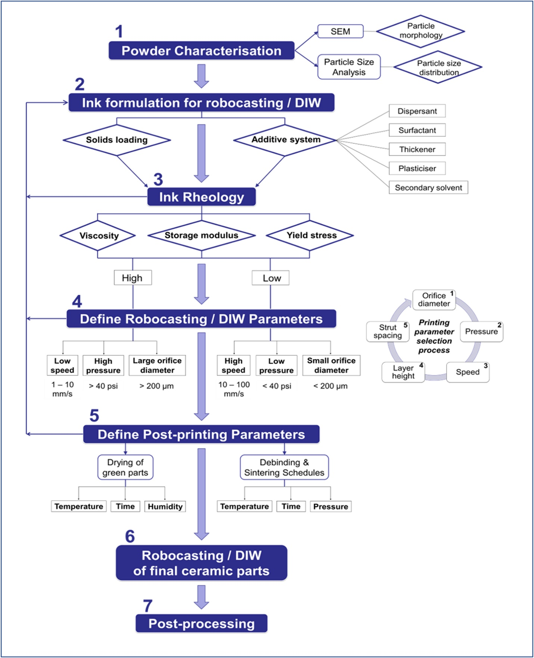

**Fig. 3.1** Methodology

**3.1 Materials**

Alumina powder (Mol Wt 101.96 g/mol) was used as the starting material. Distilled water used to prepare the suspension. The binder used was ISOBAM 104 (Kuraray Co., Ltd, Osaka, Japan) was used as dispersant and binder.

**3.2 Sample Preparation for rheological study**

To prepare the slurry for rheological analysis, alumina powder and ISOBAM 104 was mixed along with the distilled water. The content of ISOBAM 104 was taken as 0.4 wt% and alumina content was 60, 65, 70 and 75 Wt%

**3.3 Characterization**

The crystallinity of alumina powder was determined using X-ray diffraction technique (XRD). Scanning was carried out in the range 20º ≤ 2θ ≤ 90º at a scan rate of 0.02 s-step-1 and using a scan size of 0. 02o. The morphology study of alumina powder was done using a field emission scanning electron microscope (FESEM). The rheological behavior of all the pastes was determined with respect to shear rate to assess the flow properties of the paste using rheometer (MCR 51, Anton Paar, Austria). Rotational Rheology test was measured using plate - plate configuration in which the slurry is sheared between upper rotating plate and lower fixed plate as seen from the side the shear stress comes from the torque. The liquid is sheared between two plates in a controlled manner as compared with cone-plate geometry. The gap between the plates was set as 0.2 – 0.3 mm.

**Table 2.** Details of concentration of alumina and binders

|  |  |  |  |
| --- | --- | --- | --- |
| Sample | Alumina (gm) | ISOBAM (gm) | Water (ml) |
| (a) | 60 | 0.4 | 39.6 |
| (b) | 65 | 0.4 | 46.6 |
| (c) | 70 | 0.4 | 53.6 |
| (d) | 75 | 0.4 | 60 |

**FESEM-EDX**

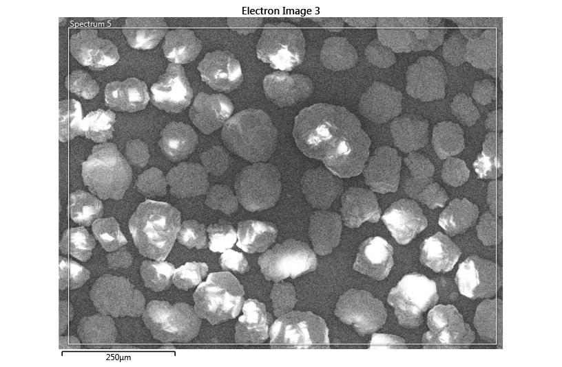

**Fig 3.2.** FESEM of Alumina Powder (250 µm)

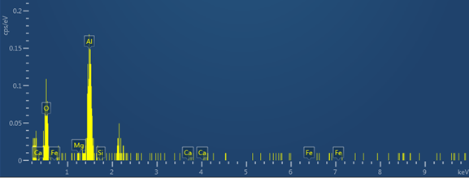

**Fig 3.3.** EDX image of Alumina (wt%)

**XRD**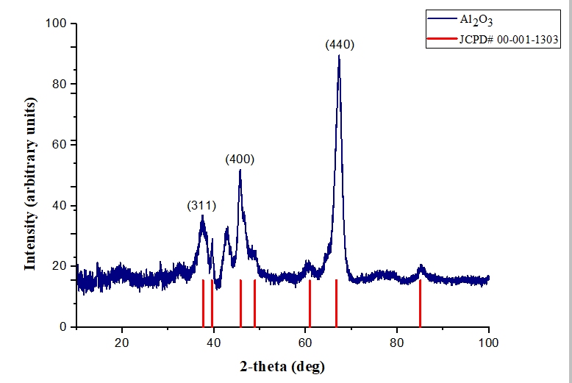

**Fig 3.4.** XRD Plot of alumina powder

**RHEOLOGY**

|  |  |
| --- | --- |
| C:\Users\Gaurav\Desktop\New folder (3)\amay graph\graph 1.PNG | **(b)** |
| **(c)** | **(d)** |
| **Fig 3.5.** Plot of viscosity and shear stress of slurry vs shear rate, (a) Sample –A, (b) Sample-B, (b) Sample-C and (d) Sample-D | |

**Chapter 4**

Future Scope

Despite the substantial advancement that has been recently made in the Direct Ink Writing (DIW) of ceramic materials such as Alumina and Zirconia, numerous fabrications and processing challenges are still to be addressed. The exploration experiments and industrial demands have endorsed ceramics enormously to be a thrilling fresh field of application for three-dimensional (3D) manufacturing technologies. Ceramic components with extremely convoluted structures that are either very challenging to produce or unfeasible to manufacture using traditional fabrication methods can be prepared via the DIW technique. The DIW technique for ceramics manufacturing has attained huge progress and this technology might be on the brink of a commercial explosion. The most current available literature on the DIW and the steps of this process chain has been comprehensively explained.

**Chapter 5**

Conclusion

Various ceramics composition is studied and will be carried out in future with experiments on optimizing the characteristics and enhancing features of ceramics and getting the perfect composition of the ceramics in all aspects such as rheology, printing and sintering.

**References**

[1] Y. Lakhdar, C. Tuck, J. Binner, A. Terry, and R. Goodridge, “Additive manufacturing of advanced ceramic materials,” *Progress in Materials Science*, vol. 116. Elsevier Ltd, Feb. 01, 2021. doi: 10.1016/j.pmatsci.2020.100736.

[2] J. A. Lewis, J. E. Smay, J. Stuecker, and J. Cesarano, “Direct ink writing of three-dimensional ceramic structures,” *Journal of the American Ceramic Society*, vol. 89, no. 12, pp. 3599–3609, Dec. 2006, doi: 10.1111/j.1551-2916.2006.01382.x.

[3] Z. Chen *et al.*, “3D printing of ceramics: A review,” *Journal of the European Ceramic Society*, vol. 39, no. 4. Elsevier Ltd, pp. 661–687, Apr. 01, 2019. doi: 10.1016/j.jeurceramsoc.2018.11.013.

[4] J. Cesarano, “A review of robocasting technology,” *Materials Research Society Symposium - Proceedings*, vol. 542, pp. 133–139, 1999, doi: 10.1557/proc-542-133.

[5] L. del-Mazo-Barbara and M. P. Ginebra, “Rheological characterisation of ceramic inks for 3D direct ink writing: A review,” *Journal of the European Ceramic Society*, vol. 41, no. 16. Elsevier Ltd, pp. 18–33, Dec. 01, 2021. doi: 10.1016/j.jeurceramsoc.2021.08.031.

[6] A. U. Khan, N. Mahmood, and P. F. Luckham, “Rheological Characterization of Alumina Ceramic Suspensions in Presence of a Dispersant and a Binder,” *J Dispers Sci Technol*, vol. 33, no. 8, pp. 1210–1217, Aug. 2012, doi: 10.1080/01932691.2011.605646.

[7] N. Liu *et al.*, “Direct ink writing of dense alumina ceramics prepared by rapid sintering,” *Ceram Int*, vol. 48, no. 20, pp. 30767–30778, Oct. 2022, doi: 10.1016/j.ceramint.2022.07.028.

[8] S. Mamatha, P. Biswas, P. Ramavath, D. Das, and R. Johnson, “3D printing of complex shaped alumina parts,” *Ceram Int*, vol. 44, no. 16, pp. 19278–19281, Nov. 2018, doi: 10.1016/j.ceramint.2018.07.153.

[9] F. Alvarez., “Optimization of the sintering thermal treatment and the ceramic ink used in direct ink writing of α-Al2O3: Characterization and catalytic application,” *J Eur Ceram Soc*, vol. 42, no. 6, pp. 2921–2930, 2022, doi: 10.1016/j.jeurceramsoc.2022.01.032.

[10] David, “Transparent alumina ceramics fabricated by 3D printing and vacuum sintering,” *J Eur Ceram Soc*, vol. 41, no. 1, pp. 781–791, 2021, doi: 10.1016/j.jeurceramsoc.2020.07.051.

[11] A. Ghazanfari, W. Li, M. Leu, J. Watts, and G. Hilmas, “Mechanical characterization of parts produced by ceramic on-demand extrusion process,” *Int J Appl Ceram Technol*, vol. 14, no. 3, pp. 486–494, May 2017, doi: 10.1111/ijac.12665.

[12] L. Yang, X. Zeng, and Y. Zhang, “3D printing of alumina ceramic parts by heat-induced solidification with carrageenan,” *Mater Lett*, vol. 255, Nov. 2019, doi: 10.1016/j.matlet.2019.126564.

[13] Sindi, “Fabrication of complex shaped alumina parts by gelcasting on 3D printed moulds,” *Ceram Int*, vol. 46, no. 3, pp. 3177–3182, 2020, doi: 10.1016/j.ceramint.2019.10.021.

[14] S. S. L. Chan, R. M. Pennings, L. Edwards, and G. V. Franks, “3D printing of clay for decorative architectural applications: Effect of solids volume fraction on rheology and printability,” *Addit Manuf*, vol. 35, no. December 2019, p. 101335, 2020, doi: 10.1016/j.addma.2020.101335.

[15] Y. Shi and W. Wang, “3D inkjet printing of the zirconia ceramic implanted teeth,” *Mater Lett*, vol. 261, p. 127131, 2020, doi: 10.1016/j.matlet.2019.127131.

[16] K. Rane, M. A. Farid, W. Hassan, and M. Strano, “Effect of printing parameters on mechanical properties of extrusion-based additively manufactured ceramic parts,” *Ceram Int*, vol. 47, no. 9, pp. 12189–12198, 2021, doi: 10.1016/j.ceramint.2021.01.066.

[17] C. Liu, X. Cheng, B. Li, Z. Chen, S. Mi, and C. Lao, “Fabrication and characterization of 3D-printed highly-porous 3D LiFePO4 electrodes by low temperature direct writing process,” *Materials*, vol. 10, no. 8, 2017, doi: 10.3390/ma10080934.

[18] A. Barki, “Linking Rheology and Printability for Dense and Strong Ceramics by Direct Ink Writing,” *Sci Rep*, vol. 7, no. 1, pp. 1–10, 2017, doi: 10.1038/s41598-017-06115-0.

[19] S. et al Savio, “Fabrication of molybdenum disilicide components by slip casting,” *Mater Lett*, vol. 57, no. 1, pp. 43–47, 2002, doi: 10.1016/S0167-577X(02)00696-1.

[20] K. Zhu *et al.*, “Additive manufacturing of SiO2–Al2O3 refractory products via Direct Ink Writing,” *Ceram Int*, vol. 46, no. 17, pp. 27254–27261, 2020, doi: 10.1016/j.ceramint.2020.07.210.

[21] C. Xu, B. Quinn, L. L. Lebel, D. Therriault, and G. L’espérance, “Multi-Material Direct Ink Writing (DIW) for Complex 3D Metallic Structures with Removable Supports,” *ACS Appl Mater Interfaces*, vol. 11, no. 8, pp. 8499–8506, Feb. 2019, doi: 10.1021/acsami.8b19986.

[22] T. Minasyan, S. Aydinyan, E. Toyserkani, and I. Hussainova, “Parametric study on in situ laser powder bed fusion of Mo(Si1−x,Alx)2,” *Materials*, vol. 13, no. 21, pp. 1–17, 2020, doi: 10.3390/ma13214849.

[23] H. Shao, D. Zhao, T. Lin, J. He, and J. Wu, “3D gel-printing of zirconia ceramic parts,” *Ceram Int*, vol. 43, no. 16, pp. 13938–13942, 2017, doi: 10.1016/j.ceramint.2017.07.124.

[24] R. B. Schwarz, S. R. Srinivasan, J. J. Petrovic, and C. J. Maggiore, “Synthesis of molybdenum disilicide by mechanical alloying,” *Materials Science and Engineering A*, vol. 155, no. 1–2, pp. 75–83, 1992, doi: 10.1016/0921-5093(92)90314-Q.